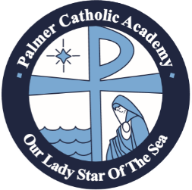

2017-2018 PALMER CATHOLIC ACADEMY
COMMUNITY PARTNERSHIP OPPORTUNITIES

GOLD - $5,000
EXCLUSIVE CARPOOL LINE FENCE BANNER (for Current School Year)
PALMER PRIDE SPONSOR BOARD (for Current School Year)
OLSS GOLF CLASSIC HOLE SPONSOR
TABLE FOR TEN AT THE OLSS/PCA ANGEL BALL OR OLSS GOLF CLASSIC FOURSOME
LOGO SPACE ON PCA WEBSITE
QUARTERLY FACEBOOK RECOGNITION
LOGO SPACE ON CONCESSION STAND MONITOR

SILVER - $2,500
PALMER PRIDE SPONSOR BOARD (for Current School Year)
OLSS GOLF CLASSIC HOLE SPONSOR
2 TICKETS TO OLSS/PCA ANGEL BALL
LOGO SPACE IN WEEKLY THURSDAY UPDATE
QUARTERLY FACEBOOK RECOGNITION
LOGO SPACE ON CONCESSION STAND MONITOR

BLUE - $1,000
LOGO SPACE IN WEEKLY THURSDAY UPDATE
QUARTERLY FACEBOOK RECOGNITION
LOGO SPACE ON CONCESSION STAND MONITOR

SPACES ARE LIMITED AND WILL BE ASSIGNED FIRST COME, FIRST SERVE

BUSINESS NAME:

CONTACT NAME:

CONTACT PHONE:

CONTACT EMAIL:

PARTICIPATION LEVEL (PLEASE CIRCLE):

GOLD SILVER BLUE

Mission Statement: Palmer Catholic Academy of Our Lady Star of the Sea Catholic Church provides a Catholic and
Christ-centered educational environment that inspires all students to reach their full spiritual and academic potential.

